EXPERIMENT-1

NAME: K.YASWANTH REDDY
REG.NO: 192425393
COURSE CODE: CSA1004
COURSE NAME: Software Engineering for Scalable Systems

STEP 1
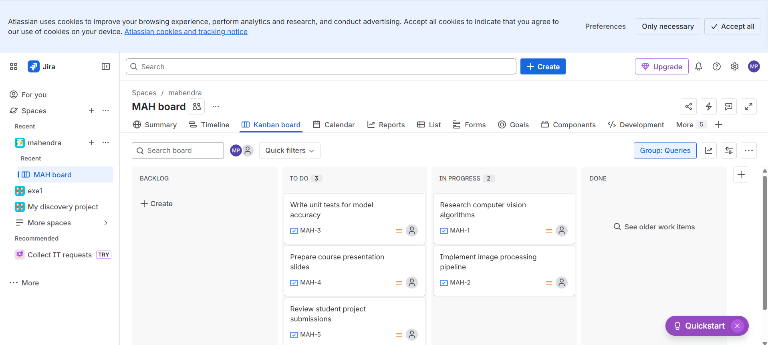

STEP 2
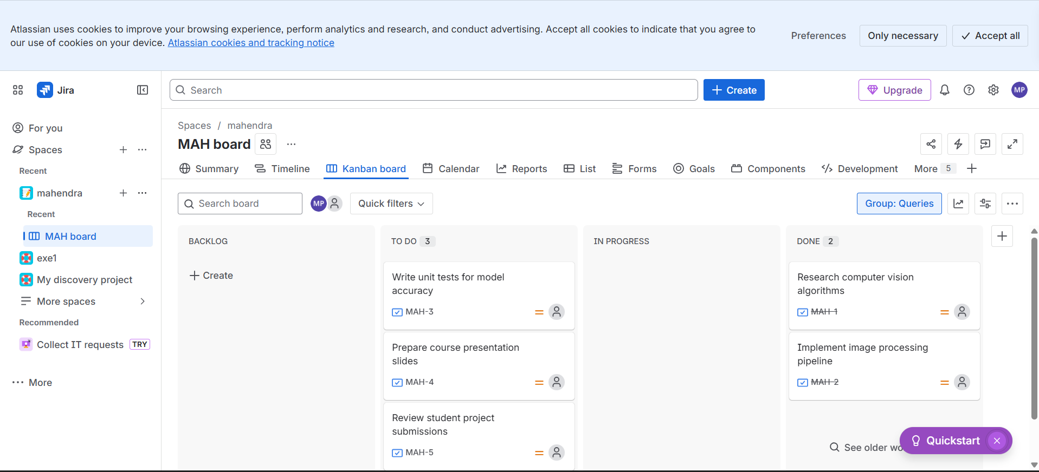
STEP 3
